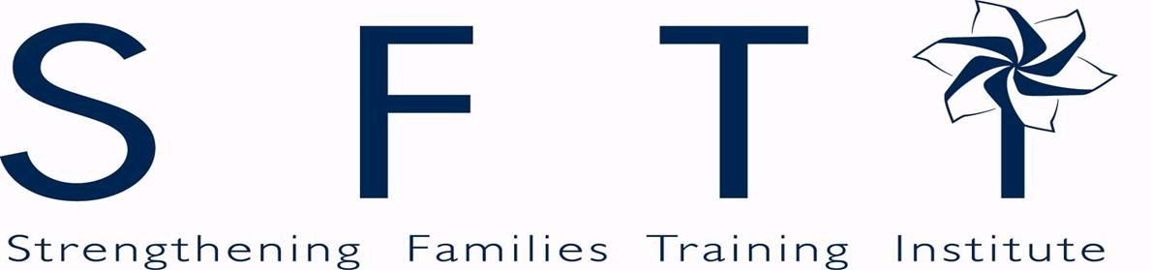



17th Annual Statewide Training Event

**2016 Strengthening Families Training Institute**

**Connect the Dots**

**March 15-16th, 2016**

**Riverside Hotel**

2900 Chinden Blvd, Boise ID 83714

 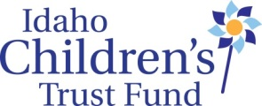

The Board of Directors

of the Idaho Children’s Trust Fund Salutes:

**The Idaho Foster Youth Advisory Board**

*Winner of this year’s Ed Van Dusen Legacy Award*

**And all Idahoans working to strengthen families**

**to prevent child abuse and neglect.**

**Board Members:**

James Herrmann, Sagle Brenda Stanley, Pocatello

REGION I REGION VI

Jeanette Pinkham, Lapwai Janet Goodliffe, Rexburg

REGION II REGION VII

Celia Asumendi, Caldwell Amanda Peña

REGION III Department of Health & Welfare

Sarah Leeds, Boise Shannon Dunstan

REGION IV - Board Chair Department of Education

Jill Andrus, Jerome Kay Christenson

REGION V Office of the Attorney General

**Staff:**

Roger Sherman,Executive Director

Lisa Newhouse, Administrative Assistant

Taryn Yates, Grants Manager/Planner

Norma Pintar, VISTA Training Coordinator

Treasure Valley Initiative to Prevent Child Sexual Abuse

1

|  |
| --- |
| Tuesday – March 15  8:00 a.m. Registration and breakfast |
| 8:45 - 9:00 Welcome, introductions and housekeeping |
| 9:00 - 10:15 Keynote Address |
| 10:15 - 10:30 Break |
| 10:30 - 12:00 Community Workshop |
| 12:00 - 1:00 Lunch |
| 1:00 - 2:30 Workshop Session 1 |
| 2:30 - 2:45 Break |
| 2:45 - 4:15 Workshop Session 2 |
|  |
| Wednesday – March 16  8:00 a.m. Registration and breakfast |
| 8:45 - 9:00 Welcome, introductions and housekeeping |
| 9:00 - 10:30 Workshop Session 3 |
| 10:30 - 10:45 Break |
| 10:45 - 12:15 Workshop Session 4 |
| 12:15 - 2:30 Luncheon: closing panel & presentation of Ed Van Dusen Award |

SFTI Schedule At A Glance…

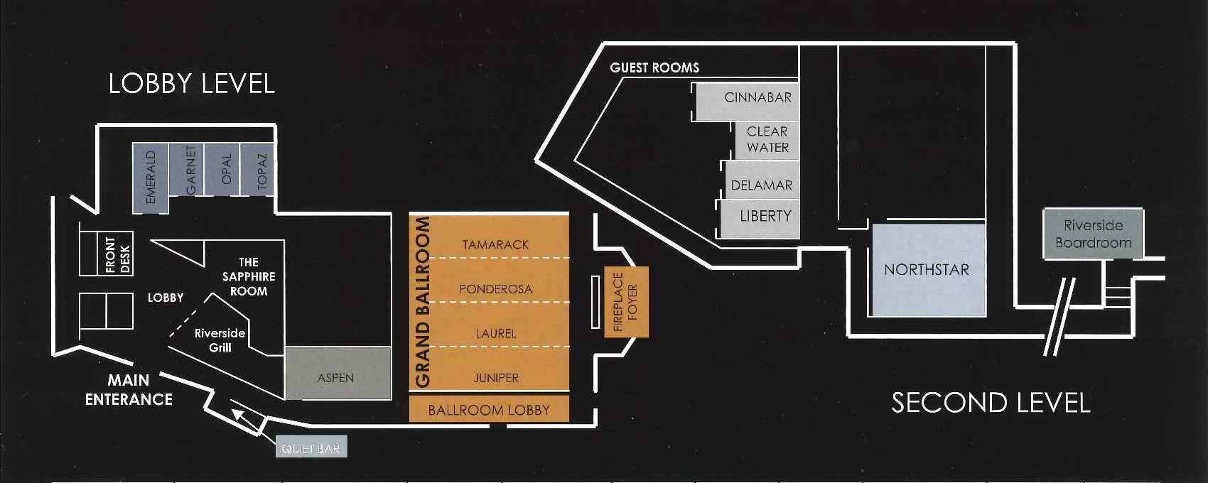

2

Riverside Conference Room Map

**Notes & Doodles…..**

**What’s your dot?**

Welcome to our 17th Strengthening Families Training Institute!

Whether you are working in

* an early childhood program
* juvenile or adult corrections
* child care
* a child advocacy center
* a hospital
* a school

Or whether your role is as

* a social worker
* a teacher
* a nurse
* a trainer
* librarian
* a business person

And besides what you do for work, you are

* a mom or a dad,
* a coach,
* a Sunday school teacher,
* a mentor…
* a neighbor

**You have a dot!**

The theme for this year’s training institute is **Connect the Dots** because what each of us does is a dot and each of us has a role to play in improving the lives of children and families. That’s why you are here for the next couple of days. We are all part of a statewide and national, hopefully worldwide, movement to strengthen families and create the kinds of safe, stable nurturing relationships and environments that children need to thrive.

So talk to some people you don’t know. Find out what they do. Listen and participate in some workshops on things that are new to you. Figure out how what they do and what they are working on connects to what you do and what you are working on. Help connect the dots across town, across Idaho and across the country! Now--what’s your dot?

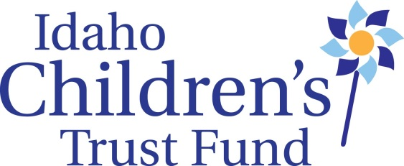 -Roger Sherman, Executive Director



3

Tuesday, March 15

One Million Strong and Counting!

*It’s time for us to celebrate our accomplishments!*

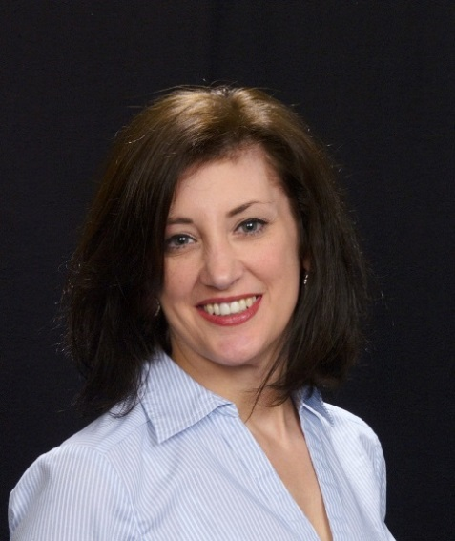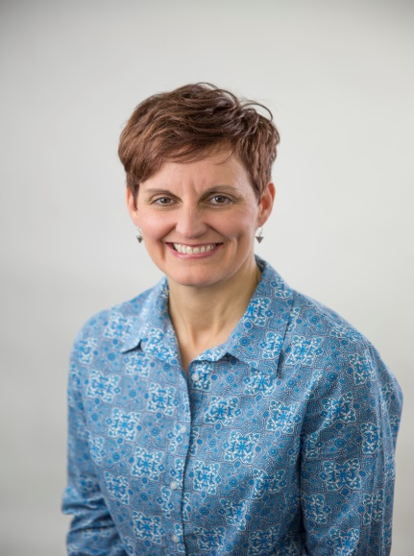

Darkness to Light (D2L) recently celebrated the one millionth person trained to prevent child sexual abuse using the research based Stewards of Children curriculum that many organizations throughout Idaho are using. By the time of the Training Institute almost 10,000 Idahoans will have been trained through your efforts! Cindy McElhinney and Paula Sellars who will share the podium as our opening keynote speakers, have each had a significant hand in making that happen, both in Idaho and nationwide.

In their shared keynote, Cindy and Paula will discuss the state of prevention efforts worldwide, having recently returned from India, along with best practices and challenges going forward. They will update us on what’s new in prevention efforts at Darkness to Light, what successful community initiatives look like, what is the tipping point and why it’s important, evaluation of prevention programs, and current successes in Idaho, followed by Q&A from the audience.

In her role as the Director of Programs at Darkness to Light for the past 6 years, Cindy has worked tirelessly to position D2L as the leader in prevention programs. She is passionate about child sexual abuse prevention and is committed to ensuring that D2L programs are widely accessible and the most effective at educating the mind and moving the heart of adults so that all children are protected.

Paula Sellars**,** MSW, is the author of Darkness to Light’s Stewards of Children**™**, a child sexual abuse prevention Docutraining® that uses consciousness training to effect behavior change. SheisExecutive Vice President of Phoenix Possibilities Inc., a company that fosters social change and leadership through the skills of personal risk. Formerly a family therapist and cranio-sacral therapist, Paula specialized in family systems, adolescence, and trauma recovery. She is also the author of Partnerships in Motion, a skill based Docutraining® that shifts the paradigm of aging to one of partnership and mutual contribution. As a consciousness trainer with Phoenix Possibilities, Paula teaches the Cliff Jumping® Program and other leadership development programs for individuals, couples, and organizational groups. As a social change agent, she weaves her knowledge of the Enneagram, Spiral Dynamics and the Cliff Jumping Program to move communities to action. Paula inspires vitality, spiritual connection, integrity and personal fulfillment.



**Darkness to Light is a national nonprofit located in South Carolina. It is focused on empowering individuals and mobilizing communities to prevent child sexual abuse.**

4

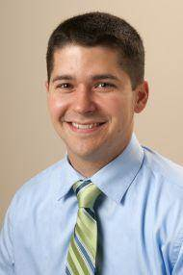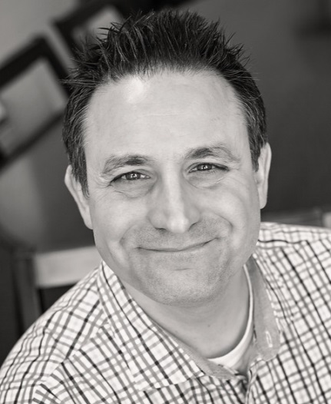Perception, Practice, Positivity and the Science of Social Norms

Ben Tanzer,AM/MSW, Senior Director of Strategic Communications at Prevent Child Abuse America and Bart Klika, PhD, Associate Professor of Social Work at University of Montana, will end our first morning with an interactive session focused on the science of social norms.

So, just what are social norms?  I work with kids and families, why should I care about the science of social norms?  How does knowing the public's perception of parenting norms or the prevention of child abuse and neglect help us better work with families? This session will address the science and practice behind social norms, while also providing a unique opportunity for the audience and presenters to interact with one another as we explore how to introduce social norms to our work of preventing child abuse and neglect.

The session is built around the *Spirit-Science-Action-Return* framework championed by The Montana Institute. We will begin by ensuring that you understand social norms and recognize that you are already involved in social norms work in your home communities. We will then move into a discussion focused on why you do the work you do. From there we will lead a dialogue where you will be challenged to identify the three norms you want to grow, and then how you can do so. The session will close with an exploration of both what things you can expect when you look to grow norms, but also the promise that awaits you when you do.



5

Tuesday, March 15, 2016

|  |
| --- |
| 8:00 a.m. Registration and breakfast |
| 8:45 - 9:00 Welcome, introductions and housekeeping |
| 9:00 - 10:15 Keynote Address |
| 10:15 - 10:30 Break |
| 10:30 - 12:00 Community Workshop |
| 12:00 - 1:00 Lunch |
| 1:00 - 2:30 Workshop Session 1 |
| 2:30 - 2:45 Break |
| 2:45 - 4:15 Workshop Session 2 |

**Workshop Session 1:**

***1A:* Engaging Diverse Families to Strengthen Nurturing Parenting Practices** *LIBERTY*

*Janie Mendez, MSW, Tina Townsend, MSW, Gabby Smith, Gabriela Tapia, BSW,*

*Mariza Munoz, JD*

A panel discussion that will include Catholic Charities of Idaho’s staff “first responders” to families seeking immigrant integration services that include: parenting strategies, bridging cultural values and beliefs, and advocacy & immigration services. This workshop will focus on CCI’s experience working with refugee and immigrant families to build a shared understanding of nurturing/positive parenting practices, and strengthen linkages between families, providers and resources in our Idaho communities. Participants will explore recruitment strategies, effective engagement and retention strategies, and unique challenges in working with diverse language, ethnic and cultural groups.

***1B:* Strengthening Families 101: The Protective Factor Framework** *EMERALD*

*Jane Zink, MA*

Join this workshop for an interactive introduction to the Strengthening Families Protective Factor Framework. Learn about the research behind the framework, explore the role of the Protective Factors in your own life, and discuss the implications for your work, your organization, and your community. Participants will leave the workshop with a personal action plan and strategies that can be implemented immediately.

***1C:* Why Words Matter: Message, Public Engagement, and** *CLEARWATER*

**Connecting the Dots** - *Ben Tanzer, AM (MSW)*

Why doesn’t more of the public take responsibility for social change? Prevent Child Abuse America believes the answer to this question lies in how we communicate with the public and this session will discuss what we are doing to address that. Ben will also address how we can amplify and multiply our efforts by connecting the dots across the country.

***1D*: Avoiding Scientific Stagnation: ACE’s Onward!** *NORTHSTAR*

*Bart Klika, MSW, PhD*

The impact of the Adverse Childhood Experiences Study does not lie in the questions that the study answered but in those that it posed. In this presentation, Dr. Klika will discuss the impact of the ACEs study and will review other relevant research that informs the development of trauma-informed systems of care. Dr. Klika will raw upon his own research to discuss how the findings of the ACEs study and other studies examining the impacts of cumulative risk, inform the development of prevention and treatment programs.

6

**Workshop Session 2:**

***2A:* Extending Our Reach: Connecting Rural Idaho through Stewards of** *EMERALD*

**Children Child Sexual Abuse Prevention Initiative**-

*Katie Simmons & Jill Donnelly*

This workshop will address the successes and challenges of building the Darkness to Light program in rural Idaho during the last 3 years. Follow the ICARE program as we take you on our journey of connecting the dots within communities to protect children and educate adults.

**2B: Promoting Gender Equity through Healthy Fatherhood** *LIBERTY*

*Bryan Lyda & Jeff Matsushita*

Participants will examine the links between child abuse, gender violence, and multiple intersecting oppressions. We will take a deeper look into how rigid gender roles and socialization show up in the lives of those we serve. Finally, we will identify strategies to promote healthy fatherhood and gender equity in our communities. While serving individuals is vital to our work, we must also make strides to counter the oppressions which make violence a common occurrence.

**2C: Say YES to Safe Sleep** *CLEARWATER*

*Jim McKay*

Too many children never reach their first birthday because of preventable sleep-related deaths. Learn how one state has partnered with various public and private entities across the social-ecology, in order to prevent incidents of sleep related deaths and injuries. This session will outline lessons learned from West Virginia's Our Babies: Safe & Sound campaign. This multi-faceted cross-system campaign works to reduce infant mortality rates and promote infant safety by working with hospitals, home visiting programs, community partners and implementing a positive community norms process. The campaign features communications materials and messaging that have been replicated in several other states including Oklahoma, Maine and Virginia. The session will also highlight results and tools developed as part of the Say YES to Safe Sleep Hospital Based Pilot Project. This approach is modeled upon groundbreaking work led by nationally recognized safe sleep expert, Dr. Michael H. Goodstein, MD, FAAP. All materials are based on American Academy of Pediatrics guidelines for infant safe sleep.

**2D:**  **Ethics: Cultural Humility** *NORTHSTAR*

*Alyssa Reynolds, LCSW*

This workshop will introduce you to the concept of cultural humility utilizing segments of the documentary film People, Principles and Practices by Vivian Chávez. Through small and large group discussion we will connect the principles of life-long learning, critical self-reflection and recognizing and changing power imbalances with NASW code of ethics principles and standards and the Idaho Bureau of Licenses social workers code of professional conduct.

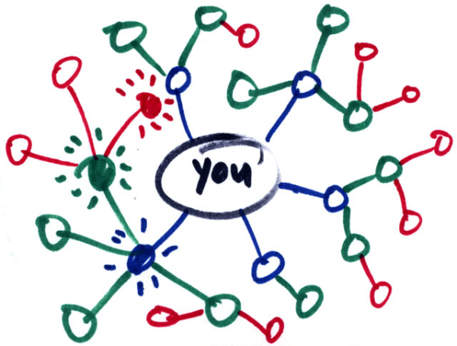

7

Wednesday, March 16, 2016

|  |
| --- |
| 8:00 a.m. Registration and breakfast |
| 8:45 - 9:00 Welcome, introductions and housekeeping |
| 9:0 - 10:30 Workshop Session 3 |
| 10:30 - 10:45 Break |
| 10:45 - 12:15 Workshop Session 4 |
| 12:15 - 2:30 Luncheon: Birth Parent Panel & Presentation of Ed Van Dusen Award |

**Workshop Session 3:**

***3A:* Breaking the Chain: The Life Cycle of an Offender and** *DELAMAR*

**Introducing the Protective Factors**-

*Janet Guerin, MSW, Jane Zink, Jane Hardison, BA & Wickes MacColl, M.Ed*

Lessons learned from introducing the Protective Factors to female offenders through the use of Strengthening Family Parent Workshops and Protective Factor Workshops. How understanding the Protective Factors can benefit them individually and help them make healthier parenting decisions, resulting in healthier children from the view points of the facilitators and participants in these programs.

***3B:* Self Care Workshop** *LIBERTY*

*Melissa Bernier, LMSW*

Enjoy fun and games while learning about how to take care of you. Participants will engage in a high energy, playful atmosphere while learning tools and techniques to care for themselves as they care for others.

***3C:* Bystanders Protecting Children From Boundary Violations** *NORTHSTAR*

**and Sexual Abuse**- *Cindy McElhinney and Paula Sellars*

Participants will learn how to be an active bystander in child sexual abuse prevention and response. Examples of boundary violations and inappropriate behaviors will be given and how bystanders can make spontaneous and planned interventions that reinforce boundaries and protect children. This course is a supplement to Darkness to Light’s Stewards of Children. Participants will also be given information on how this course can be provided to communities in Idaho through the facilitator network.

***3D:* Strengthening Families through Parents Anonymous: The First Year** *CLEARWATER*

*Allison Demarest and Alicia Benningfield*

This workshop will discuss the alignment of the national Parents Anonymous program, a parent support and leadership development program, with the Strengthening Families Framework. Presenters will also discuss the research that qualifies it as an evidence-based practice and explore the experience that Family Advocates has had implementing the program. Presenters will share anecdotes of success and outcomes for the first year.

8

**Workshop Session 4:**

***4A:* BabySteps and Beyond: Early Intervention & Nurturing Families** *CLEARWATER*

**through the Critical Years**- *Heather Kemp, BS*

Working with families from the prenatal stage and throughout the first 4 years has been a goal of the Family Resource Center in Pocatello. We will discuss how families are moving through programming, the benefits of receiving long term services and building & maintaining relationships with families. Please be ready to share your experiences in working with families and what has worked for you.

***4B:* The Raising of America** *NORTHSTAR*

*Beth Oppenheimer and Taryn Yates, MSW*

Episode 3 of the documentary series The Raising of America: Early Childhood and the Future of our Nation is entitled Are We Crazy About our Kids? The episode asks what are the economic benefits reaped by investing affordable, high quality early care and preschool and examines outcomes found in programs found in Canada and Utah.  What they discovered was that investments in high quality child care and preschool pays for itself in many ways and many times over, yielding huge individual- and societal- benefits.  So, why aren’t we making this investment nationwide?  What will it take to make us crazy about our kids?

Workshop presenters will introduce the film and facilitate conversation about how it can be used in our communities to spark a badly needed conversation about early childhood.

**4C: A Path Forward: Policy Options for Protecting Children** *DELAMAR*

**from Child Abuse and Neglect Fatalities**- *Jim McKay*

This session will review deliberations and recommendations from the federal Commission to Eliminate Child Abuse and Neglect Fatalities (CECANF). The enactment of the Protect Our Kids Act in January 2013 established the Commission with the charge to produce a national strategy and recommendations for reducing fatalities across the country. In speaking about the legislation at the time of the vote, lead bill sponsor Rep. Lloyd Doggett (D-TX) emphasized that “there is more that we can do and must do” to protect our nation’s most vulnerable children and prevent child deaths from abuse and neglect. We will review the recommendations of the Commission and learn what we can do to get them implemented.

***4D:* Crying Plan Implementation** *LIBERTY*

*Sherry Iverson, RN, BS and Beverly Haugen*

In 2014 the Idaho Crying Plan was developed to respond to the increase in abusive head trauma or shaken baby syndrome being seen in Idaho hospitals.  Since then the plan is being used statewide but not everywhere. This workshop will focus on how to take the crying plan to full implementation.  We are pretty happy about how far it has gone so far:  into most of the birthing hospitals, through some of the home visiting programs, and into child care programs throughout the state.  Unfortunately though, at this point we can only say “most of” and “some”.  Join us to figure out how to get it to **all**!

9

Wednesday, March 16

*Leave inspired! On Wednesday afternoon, we will close with a panel from the*

*Birth Parents National Network……*

**Changing Lives through the Protective Factors**

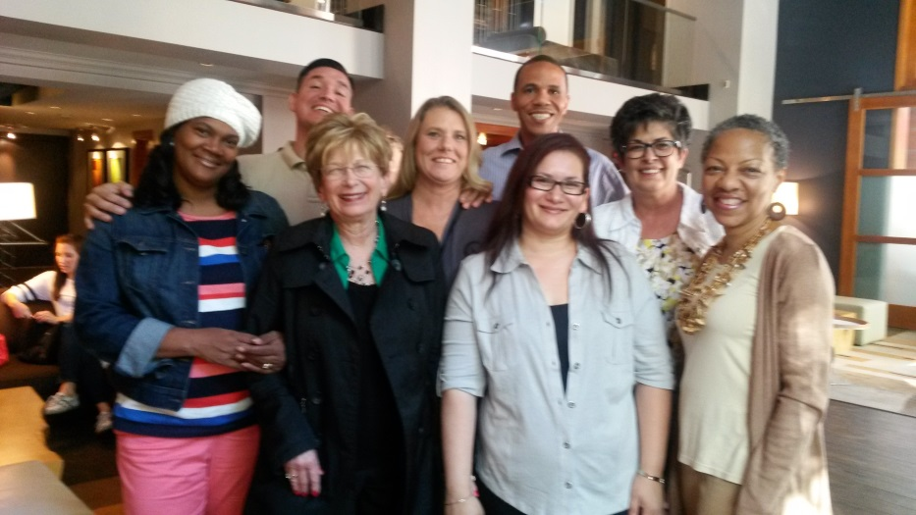Three parents from the Birth Parents National Network will close the 2016 Strengthening Families Training institute. During a moderated panel presentation, these strong, diverse and passionate parent advocates will share their personal life experiences as parents and how they built protective factors within their own lives and the lives of their families.

Corey Best from Florida, Janae Moss from Utah and Sandra Killet from New York City, have each faced their own parenting challenges and each now leads efforts in their states and nationally to support other parents and to build parent leadership.

They will discuss how they work to strengthen and support families and are now engaged in designing systems and policies that work for families in their own communities and at the state and national levels. These panelists will talk about their own life experiences in using prevention services and types of prevention services that are needed by families within their own communities. They will also share their perspectives as parents about recommendations on specific prevention policies and practices that they believe would benefit families.

Meryl Levine, the lead on the National Alliance of Children’s Trust and Prevention Fund’s parent partnership projects and child neglect prevention initiative, will moderate the panel.



10

Presenter Biographies

**Jill Donnelly** has been a family support coordinator for the ICARE program of St. Vincent de Paul since March of 2012. Graduate of the University of Idaho, she holds a Bachelor’s of Science degree in Child Family and Consumer Studies with an emphasis in Family Life. Jill’s professional credentials include; certified Parents as Teachers parent educator, certified Nurturing Parenting class facilitator, certified Circle of Security Parenting class facilitator and authorized Stewards of Children Child Sexual Abuse prevention workshop facilitator. Jill is a native of Oregon and currently lives in Coeur d’Alene, ID with her husband and two children.

**Janet Guerin, MSW** has worked in the Idaho Department of Corrections for over 24 years and specializes in working with female offenders. She currently manages the East Boise Community Reentry Center for women and manages the Strengthening Families Protective Factors grant for IDOC. Janet is a graduate of the University of South Dakota with a Bachelor in Sociology/Criminal Justice/Political Science and a Master of Arts in Counseling, Guidance and Personnel Services. She is an Idaho Licensed Social Worker.

**Jane Hardison** has a BA from Stanford University and a long history of volunteering in the Boise Schools, with the Boy Scouts and the Boise YMCA.  Most recently she was trained to be a facilitator of the Strengthening Families Parent Workshops and provided this program at four locations in Boise for female offenders.  She has also been a facilitator of the Protective Factors Workshops at the East Boise Community Reentry Center.

**Sherry Iverson, RN**, is the Director of St. Luke’s Children’s Hospital’s Advocacy and Community Education program, the Executive Director of the Idaho chapter of the American Academy of Pediatrics and an adjunct health sciences faculty member at Boise State University.

**Heather Kemp** is aNational Trainer with the Nurturing Parenting Programs and is the Director of the Family Resource Center at Bannock Youth Foundation. Her role with the agency includes parent education & support, training programs facilitators, grant writing and program management. She holds a BS in Psychology and is currently pursuing her MBA. Heather has been working with families for 19 years.

**Bryan Lyda** is an activist and ally with the Idaho Coalition Against Sexual & Domestic Violence. He has worked with adolescent men and women for over ten years in ending gender violence, unplanned pregnancy and sexually transmitted infections. Bryan currently engages vulnerable and marginalized youth in correctional institutions, substance abuse treatment centers, job training centers and other settings. He believes that the key to creating a healthier future for Idaho lies in mobilizing young people to show up as leaders and allies in ending all forms of oppression and violence.

**Wickes MacColl, M.Ed.** is currently a Strengthening Families parent program trainer and Stewards of Children Instructor and Trainer. Wickes previously worked for the Idaho Children’s Trust Fund, the lead agency for child abuse and neglect prevention in Idaho. She was licensed as a Stewards of Children trainer in 2005 and as an instructor in 2012. Wickes led Child Sexual Abuse Prevention training for the Episcopal Church for 7 years. Prior to this, she spent 25 years as a K-8 teacher and school program developer.

11

Presenter Biographies

**Jeff Matsushita** has been a Program Specialist at the Idaho Coalition Against Sexual & Domestic Violence since 2004. The Coalition has allowed Jeff the privilege to travel, learn and be a part of the movement to end violence against women, girls and gender non-conforming community members. In this time of movement, Jeff honors individuals’ stories, the connection to one another and a solid pick-up game of basketball.

**Jim McKay** is Public Policy Consultant for the National Alliance of Children’s Trust & Prevention Funds, and also serves as the State Director of Prevent Child Abuse WV. Jim leads PCA-WV’s efforts including public policy advocacy, public engagement, media relations, and implementation of various strategic initiatives including the Our Babies: Safe & Sound campaign, Partners in Prevention, Stewards of Children, Circle of Parents®, and operations for the WV Children’s Trust Fund. Previously, Jim was Program Coordinator of Time Out Youth Shelter, a crisis shelter for runaway and homeless youth in Huntington for 5 years. From 1994-2000, Jim held various leadership positions for The Education Alliance, a non-profit promoting private support for public education. Jim served as Legislative Assistant to the Speaker of the WV House of Delegates from 1991-1994.



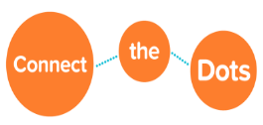**Janie Mendez, MSW** has worked for Catholic Charities of Idaho since 2005 where she began as a Family Strengthening Worker, providing direct services to families in Canyon County. As a regional and programs director, she now oversees both social services programming and immigration legal services statewide. Janie has a passion for assisting Communities of Color to raise healthy families in Idaho.

**Mariza Munoz, JD,** recently returned to Catholic Charities to join the team as part of the Immigration Legal Services program. She has over 5 years of experience assisting the Spanish speaking immigrant community providing immigration information and legal assistance.  Mariza was born and grew up in Chihuahua, Mexico where she completed her formal education and received her law degree.

**Beth Oppenheimer** has served as the Executive Director of the Idaho Association for the Education of Young Children (Idaho AEYC) since 2010. She has spent many years advocating for the needs of our children and families and is committed to advancing opportunities for all Idaho families. Previously, Oppenheimer was the Associate Director for the Student Union Building at Boise State University. She has also served as conference coordinator at the University of Idaho, and has worked on education, policy, and development issues for the Junior Achievement of the National Capital Area and the Institute for Women’s Policy Research. Beth and her husband currently reside in Boise and have two young daughters, Maddie and Annabelle.

**Alyssa Reynolds, LCSW,** is an Idaho licensed clinical social worker and has been working in

Southwest Idaho in child welfare for the past 23 years. She is currently an adjunct faculty Instructor

and the Child Welfare IV-E Scholars Coordinator at Boise State University.

12

Presenter Biographies

**Katie Simmons** has worked for the ICARE Program of St. Vincent de Paul in Coeur d’Alene, ID for the past 18 years. She has a degree in Child Development from North Idaho College. Katie’s professional credentials include; certified Parents as Teachers parent educator and supervisor, certified Nurturing Parenting class facilitator, Love & Logic facilitator and authorized Stewards of Children Child Sexual Abuse prevention workshop facilitator. In 2012, she became the Director of the ICARE program.

**Gabby Smith** is a Jesuit Volunteer serving at Catholic Charities of Idaho for the year.  She teaches English and citizenship classes to refugees in the Boise community and provides case management and advocacy services. Gabby recently graduated from Loyola University Maryland where she majored in English and Secondary Education, and was involved in several volunteer and social justice groups on campus.

**Gabriela Tapia, BSW,** has worked for Catholic Charities of Idaho since 2006. She has primarily worked with the Spanish speaking immigrant community providing parenting classes and adult literacy programming.  Gabriela was born in Zacatecas Mexico and moved to Idaho at the age of 5.

**Tina Townsend, MSW,** is certified in the Active Parenting Program, the Nurturing Parenting Program, and the Learning to Live Together Ethics Education for Children Program.  Tina has been a Family Strengthening Worker at Catholic Charities of Idaho since 2013 primarily advocating on behalf of individuals from various refugee populations. She is the mother of four grown children and the nana of one grandchild.

**Taryn Yates, MSW,** joined the Trust Fund staff after working for several years as the Executive Director of the National Hemophilia Foundation. Taryn moved to Boise 9 years ago after receiving her Masters in Social Work from George Mason University. She started out as a community organizer working with low-income families regarding access to affordable health care. She then went on to work as the Public Policy Director for the Idaho Women’s Network where she lobbied for child care licensing, equal pay, anti-shackling legislation, and other issues. She later segued into health-related non-profits as the Policy and Program Director for the National MS Society which led to her job at NHF. Taryn has always embraced her calling as an advocate for vulnerable populations and is dedicated to supporting efforts to improve the lives of children in Idaho.

**Jane Zink, MA,** coordinates Steps to Quality, Idaho’s Quality Rating and Improvement System for child care programs and is the Strengthening Families Coordinator at Idaho AEYC. She is the co-author of nationally recognized Strengthening Families Protective Factor Framework trainings and parent education curriculums. Jane consults with partners in the housing, child care, corrections, and advocacy sectors to implement the framework in organizations and promote the Protective Factors in families.

13

*Congratulations to:*

**The Idaho Foster Youth Advisory Board**

*This year’s recipient of the Ed Van Dusen Legacy Award for Exemplary Practice*

*in Preventing Child Abuse and Neglect*

Any of you who heard members of the Idaho Foster Youth Advisory board (IFYAB) speak at the Institute last year know the impact a group of empowered youth can have They have real life expertise to share with us on how to do this work better and create communities where children and families are healthy and supported. These young leaders are the experts in this effort and are diligently working to improve Idaho one opportunity at a time.

The IFYAB was founded in 2012 as an avenue and platform to hear the voice of foster youth in child welfare practice. The board consists of current and former foster youth across the state of Idaho. They represent the most important part of child welfare practice: the children that we aim to protect. IFYAB members are trained in a specialized leadership curriculum designed to teach them how to use their personal story to raise awareness and impact change in child wellbeing issues.

The board provides an innovative way to impact abuse and neglect by using their personal stories and experiences to influence the community. They have created more foster homes, created scholarships to send foster youth to college, created college programs on campuses for foster youth, helped educators understand the impact of abuse and foster care on education and have helped social workers, law enforcement, and judges understand what it’s like to be removed from family. In addition, they make a strong case on how important family work is to keep children safe and out of foster care. Hearing youth perspective has been very impactful in working with the

14

community and community professionals. Many changes have been made based on these conversations and IFYAB members have been invited to sit on boards of community organizations as a result.

The Idaho Foster Youth Advisory board does incredible work to educate, inform, and support youth of foster care. They are the children we wish to learn how to protect and prevent abuse from happening.

**The Ed Van Dusen Legacy Award**

The award presentedannually by the Idaho Children’s Trust Fund Board will recognize and reward a particular child abuse prevention effort in Idaho that is creative, innovative and impacts the community in a positive way by *preventing* the abuse and neglect of children.

Ed Van Dusen can rightly be called the “Father of the Idaho Children’s Trust Fund” because of his role in getting the organization established in 1985. After his death in 2009, the Trust Fund’s board renamed its “Board Award” in his honor. 2010 marked the first award given in his name.

Winners of the award receive a $1000 cash award, a statuette and will have their name engraved on a plaque in the Idaho Children’s Trust Fund office.

**Thank you to:**

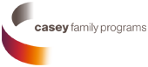

For their many contributions to the 2016 Strengthening Families Training Institute. And to the well-being of

children in Idaho and nationwide!



The Idaho Power Employee Community Charity Fund for their

generous donations.

Celebrate Child Abuse

Prevention Month in April!

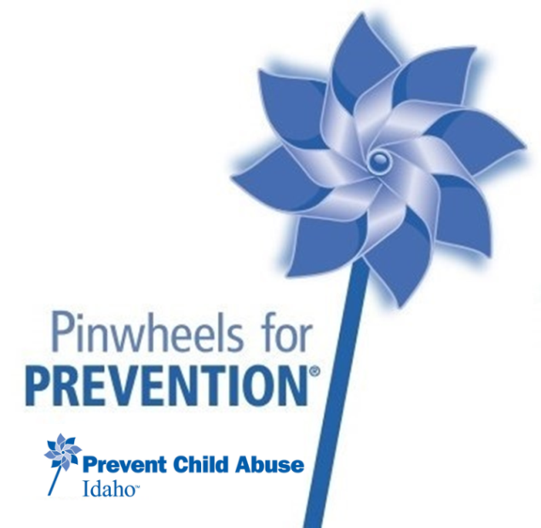

**Need pinwheels?** Talk to the ICTF Staff!

**Talk about it!** Use the media

Keep in touch with what’s going on at [www.idahochildrenstrustfund.org](http://www.idahochildrenstrustfund.org) or on Prevent Child Abuse Idaho’s Facebook page.

**Idaho Children’s Trust Fund – 304 W. State Street – Boise, ID 83702 – (208) 386-9317**