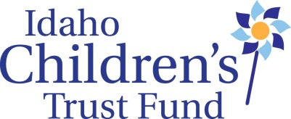

AGENDA
Idaho Children’s Trust Fund
Quarterly Board Meeting
Alexander House, 304 W. State St., Boise, ID.
October 19, 2015

Monday, October 19
8:30 am Gather for light breakfast
9:00 am: Convene
12:00 pm: Working Lunch
4:00 pm: Adjourn

Morning Session

9:00 Convene/Check ins……………………………………………………………………………………Sarah Leeds, Board Chair

9:15 Board Education—Johnna Johnson and Robert Truman from KBOI Television in Boise will present some ideas for a “Childhood Matters” media campaign that could increase ICTF’s statewide exposure.

10:00 Approve Minutes of July Meeting

Consent Agenda
  - Staff Reports
  - Financial Report
  - Fundraising Report (grants applied for/donor letter)

Discussion of Internal controls and plan for internal audit review (voluntary)

Expenditures over $1000:
- Stewards of Children materials not to exceed $5,000

Granting Decisions—Annual Grants 2015-16

Noon Working Lunch

1:00 PCAA site visit preparation/plan review

Proposals:
- VISTA Training Coordinator in Twin Falls
- 2017 Legislative session: Child Sexual Abuse Prevention Education legislation (modified Erin’s law like Texas statute)

4:00 Adjourn

