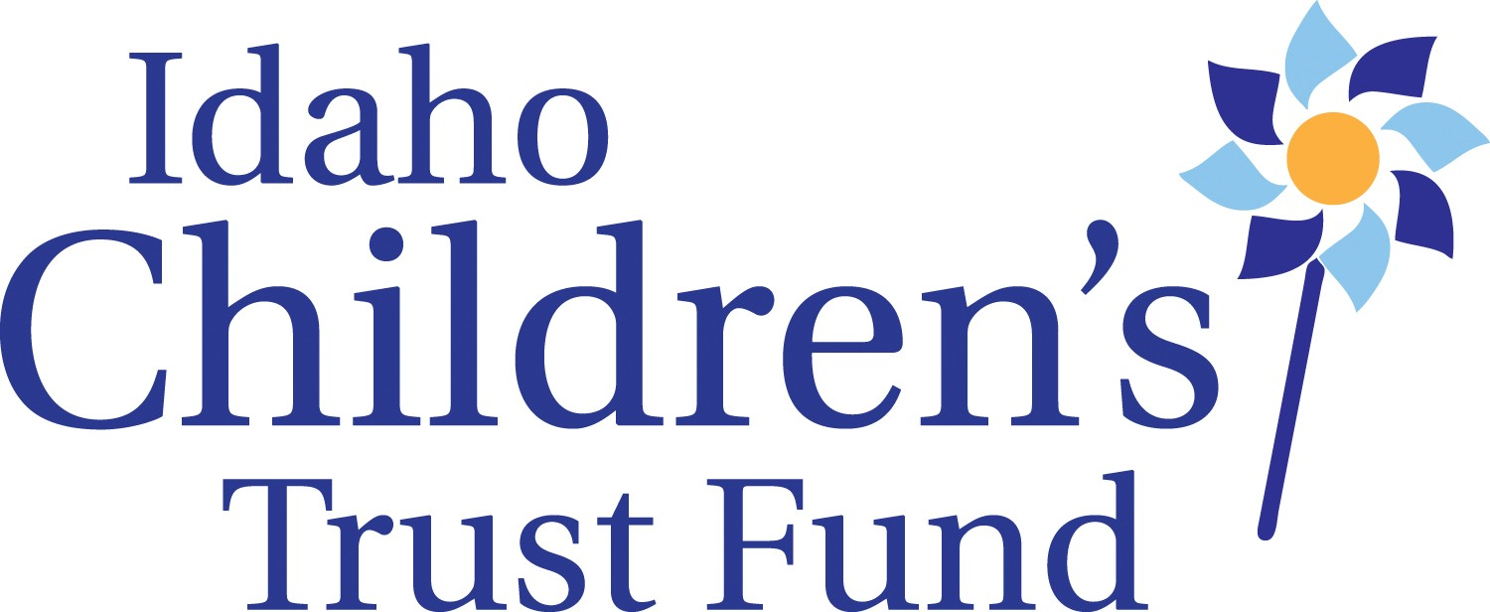

Idaho Children’s Trust Fund Board Meeting
Alexander House- 304 W. State St., Boise, Idaho
Meeting Minutes/ April 18, 2016

Call to order: Chairperson Sarah Leeds called the meeting to order at 9am on Monday April 18th

Board Members Present: Sarah Leeds, Celia Asumendi, Jill Andrus, Brenda Stanley (via phone), Janet Goodliffe, Amanda Pena, Shannon Dunstan, and Kay Christensen
Absent: Jeanette Pinkham(briefly on phone) and James Herrmann

ICTF Staff Present: Roger Sherman, Lisa Newhouse, Taryn Yates

Board Education- Intro to neglect curriculum, Plan for dissemination (grantees)
Ms. Yates presented a plan for training grantees and other practitioners so that they can develop practice around neglect prevention. Board members offered suggestions on content and dissemination.

[MSC=Motion made/seconded/carried)

MSC/Christensen/ Goodliffe that the minutes of the January meeting of the Idaho Children’s Trust Fund be approved as distributed
Motion unanimously carried

MSC/Christensen/ Goodliffe that the consent agenda (including staff reports and financial reports reviewed by the Finance Committee) be approved as distributed.
Motion unanimously carried

Personnel Discussion on 3% wage increase
Based on the Legislature’s approval of a 3% wage increase for state employees:
- Mr. Sherman will build increase into budget for finance committee to look at and board review in July
- MSC/Goodliffe/Dunstan Performance evaluations for executive director and other staff will be completed prior to July board meeting
- Motion unanimously carried

- MSC/Dunstan/Asumendi Personnel compensation will be a standing agenda item at the April board meeting
- Motion unanimously carried

SFTI Report
- 201 people attended the Training institute this year
- SFTI budget
- Budget came in over projected budget due to higher travel costs and meals (Due to state change in per diem rates from $30 to $45, food costs were higher than projected.)
- Consists of small honorariums, lots of travel
- Consideration of raising registration
CAP Month
- Staff reported that it has been a very active CAP month but that they have noticed some inconsistency on the prevention message. Discussion ensued about how to relay more appropriate messaging for CAP month
- if using pinwheels, use for prevention
- How do we get media to talk prevention rather than the negative?
- use positive messaging tactics as per the Science of the Positive described at the SFTI by Bart Klika from University of Montana and Ben Tanzer from Prevent Child Abuse America

Program/Funding Decisions
- The board affirmed their support for continuation of the Treasure Valley initiative after Norma Pintar leaves in September and affirmed their support for continuing to use VISTA staffing as long as it is paid for with funds raised for that purpose
MSC/Pena/Dunstan to support development of a child sexual abuse prevention project in the Magic Valley similar to the Treasure Valley Initiative and pursue funding with support of Magic Valley partners.

Re-organizing Ed Van Dusen Legacy Award
- Suggested for staff/board to nominate potential awardees rather than relying on groups to self-nominate
- Discussion about moving the award presentation to a fundraising event such as a plated dinner with media piece (Need to consider cost and return of a fundraiser)
- A subcommittee will be formed in July to create a plan.

Public Policy
The executive director asked that the board consider ICTF involvement in two upcoming public policy issues related to child abuse prevention.
- Interim committee on foster care reform—An interim committee made up of legislators will be formed to study and recommend changes to Idaho’s foster care system. This issue was very contentious during the session this year. Director will seek opportunities to participate in the interim committee discussions/process to insert a focus on prevention.

- Repeal of religious exemption from medical neglect statutes
- Criminal statutes related to child deaths as a result of the current religious exemption to Idaho’s medical neglect law are being reviewed and the Governor has called for the formation of a committee to consider legislation.
The state’s child death review panel has recommended that the exemption be repealed
For now the executive director will participate in the discussions and the board will review legislation once it is developed.

Board committee sessions
- A committee was formed to do the Executive Director’s Performance Evaluation made up of directors Andrus, Asumendi and Chairperson Leeds. The committee will send form to board for any additional feedback
- The policy committee is looking at creating an emergency Succession Plan that is less detailed than the South Carolina plan it received as an example. (Executive Director sent job description to the committee chair to facilitate their work)
- The board discussed some issues related to fundraising prior to the Fundraising Committee meeting upon adjournment. To wit:
- Can Board use social media/Crowd sourcing for fundraising?
- Mr Sherman to talk to Faith Cox, State Risk Manager, about liabilities at fundraisers
- Idaho Gives Day –Can a government entity participate?
- Mothers/Fathers Day- donate in honor of…..
- KBOI involvement and naming grants
- Caution was expressed in how or if ICTF should/could consider co-branding or giving naming opportunities to corporate donors.
- Fundraising committee to meet after Board adjourns

Upcoming Travel Request:
- May 16-18—Yates and Sherman to Yakima Washington for National Resource Center (CBCAP) sponsored site visit

- August 30 to September 2nd CBCAP National meeting and Office of
- Child Abuse and Neglect Conference, Washington, D.C.

- September 19 to 22nd—National Alliance of Children’s Trust and
- Prevention Funds-Scottsdale, AZ

- October 17 to 20—Prevent Child Abuse America ED meeting and
- conference, Cincinnati, OH

- MSC/Goodliffe/Andrus to approve travel requests
Approved by board

* BOARD MEETING DATES SET FOR NEXT MEETING*
July 18-19, 2 day meeting in Boise at Alexander House

Meeting Adjourned: At 1:45pm

