What’s your dot?
What role do I play in my community…..
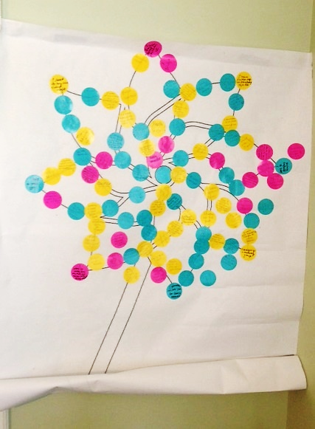
- I teach dance to children
- A bridge
- A volunteer coach
- Home visitation, educating parents in safety and abuse prevention
- Raise awareness
- Head Start Family Services
- Wife, Mother, Daughter, Volunteer
- Train protective factors
- I coach baseball and hockey
- I train partner organizations on Strengthening Families
- To spread light, love and support to those who really need it
- Child protection social worker
- I do home visits in the Healthy Families Program
- Knowledge and prevention
- I am an educator of small children and families
- Early Intervention Services
- I give good vibes
- I help children be successful at school by offering services to their families
- Coordinating systems and services at the state level
- I work to strengthen families
- Connecting families to needed resources
- Relief Nursery Interventionist
- Youth Group Coordinator
- Sunday School Teacher
- Prevent child abuse in my community and my family
- Child care provider
- Listen to teach and inspire children and families
- Stewards of Children in Pocatello
- Pray nightly with my son
- Home visitor
- Respite caregiver
- Infant Toddler Program
- Youth mentoring
- I read to my child every night
- A mom talking about hard places
- 27 years of foster parenting
- Passion and time
- Child Welfare, working with children victims and their families
- Love, accept and read to my grandchildren
- Supervise a home visitor program
- Support the hard work of parent education
- Rally parent leaders, help them find their voice, message & how to share it
- Family advocator
- Parent educator
- Child welfare
- Tribal advocate and mom
- Positive attitude
- Connecting foster youth with family
- Building community connections
- Coach and teach CR
- Celebrate recovery
- Family wellness mentor
- FACS IL Coordinator
- Birth Parent Network from HS from IDOC
- Primary Teacher
- Trauma assessment/ recovery
- Enroll my children in ‘the arts’ (theatre, music, etc)
- Child abuse prevention advocate
- Service Coordinator Social Worker
- I am a support to many families
- I am a teacher
- I work with incarcerated mothers
- I co-organize a mommy group
- I help to create SFTI
- Policy advocacy
- Giving child care providers tools and resources to improve childcare
- Watching my grandchildren grow in a safe environment
- Education!
- Coaching parents
- Providing education and safe environments for children
- Therapist intern at Juvenile Corrections
- Provide counseling to victims of child sexual abuse
- Volunteer as a big sister
- Grandparent, Trust Fund board member
- Teaching parents to be a child’s first teacher
- Read to my grandkids every night via skype
- Early Intervention Birth to 3 years
- Mom, Advocate, Home Visitor
- I work to make sure my kids are raised with strong values
- Child advocate
- Protecting children
- Head Start advocacy
- Educate adoptive parents on child abuse
- Community voice
- Works with families and children
- Early childhood education and infant mental health specialist
- Head Start Minidoka, teaching children and empowering parents
- IFYAB Youth Advocate
- Working with teens and families
- Head Start family educator
- Mom, Grandma, Neighbor, Program Manager for a home visiting program
- Infant Toddler Program
- Educating families on typical and atypical development
- Educating at risk youth
- Providing quality child care
- Social work, early intervention program
- Parent partnerships
- Serving children and families
- I provide respite care for family members
- Teaching behavioral change for at risk youth
- I lead a group that volunteers to serve at local homeless shelters, teaching kids to serve others
- Help to take care of my grandson

