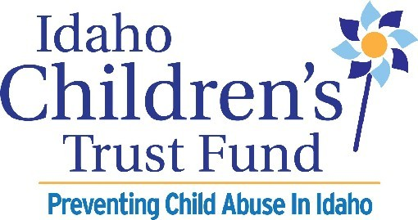

Multiyear Grant
Application

Due: June 6, 2025

Project Period:
October 1, 2025 through September 30, 2028

304 W. State St.
Boise, Idaho 83702
Phone: 208-386-9317

www.idahochildrenstrustfund.org

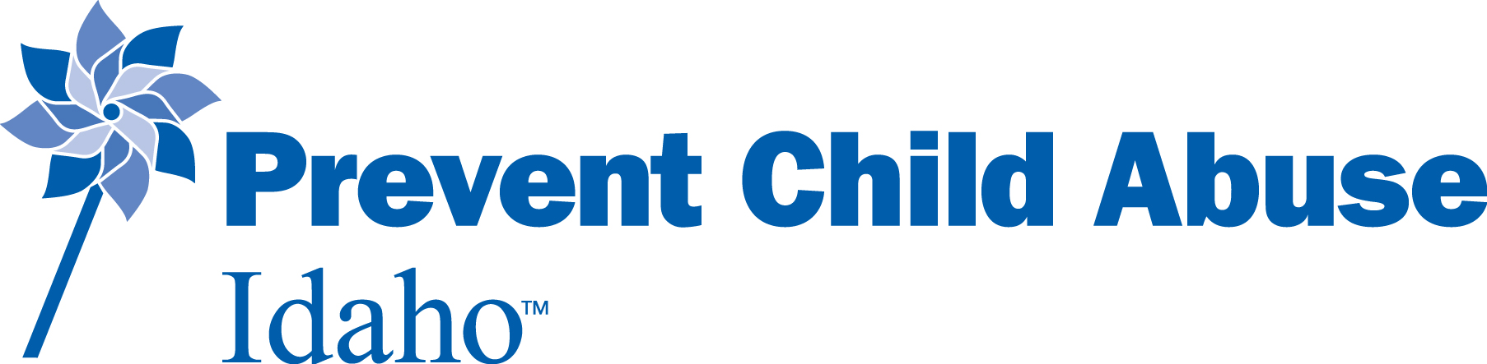

Idaho Children’s Trust Fund (ICTF) Multiyear Grant Application
Project Period: October 1, 2025 through September 30, 2028
Grant Award: $40,000

Name of Applicant Organization: ___________________________________________________________

Address: ________________________________________________________________________________

City: _________________________________________ State: ________________ Zip: _________________

Website URL (address), if available: ___________________________________________________________

Phone: ______________________ Fax: _______________________ E-mail: ________________________ _

Federal Employer Identification Number (EIN): ________________________________________________

Unique Entity Identifier (UEI) number: _______________________________________________________

Project Title_____________________________________________________________________________

Program Contact: ________________________________________________________________________

Fiscal Contact Person: ____________________________________________________________________
Official Authorized to Sign Contract
Name and Title: _ _________________________________________________________________________
Address: _ _______________________________________________________________________________
City, State, Zip: _ _________________________________________________________________________
Phone: _______________________ Fax: ___________________ E-mail: ____________________________
Authorized Signature __________________________________________ Date ________________________

The Idaho Children’s Trust Fund (ICTF) is accepting proposals that address child abuse and neglect prevention, with specific attention to child neglect prevention. This grant opportunity is for short-term three-year projects.

Idaho Statute states, “Programs contracted for with moneys are intended to provide prevention services. Prevention services means any community-based education or service program designed to prevent or alleviate child abuse or neglect and shall not include direct treatment programs.”

This funding is available to public or private non-profit and faith-based organizations, government agencies, (e.g. schools or health departments) or qualified individuals who provide community based educational or service programs designed to reduce or prevent child abuse and neglect. Entities must have an Employer Identification Number (EIN), Unique Entity Identifier (UEI) Number, an identified fiscal agent, and must provide certificates of commercial general liability insurance, worker’s compensation insurance, and W-9 form with their grant application. Applications that do not have these will not be accepted.

Maximum funding available per year from ICTF: Year 1- $14,000 Year 2- $13,000 Year 3- $13,000
Project Summary

Provide a one paragraph Executive Summary of your proposal. (No more than eight lines to describe the who, what, when, where, how, and why of your proposed project.)

Applicant Information

- In 50 words or less, state the applicant’s mission, vision, and a short history of the organization.
- In 100 words or less, describe the applicant’s experience providing child abuse and neglect prevention strategies and promoting family and community well-being.
- In 50 words or less, describe the applicant’s qualifications to receive and administer grant funds, manage reporting requirements, and deliver proposed services.
- Have you received prior grants from ICTF? Yes___ No___
- Our federal partners require that you acknowledge federal funds and our ICTF board requires that you advertise/promote the Idaho Children’s Trust Fund if your project is funded. Are you willing to do this? Yes___ No___

Project Information

- Project Description
  - In 1000 words or less, describe your project IN DETAIL and how it will strengthen families and communities to prevent child abuse and neglect BEFORE it ever occurs. What services will be offered and how will you embed the five protective factors into your project? Include curriculum information if applicable.
  - Cite research about the need for and efficacy of your project.
  - Does your project provide universal primary prevention services? Yes____ No ____

- Fill in the blank and/or answer the following questions:
  - It is estimated this project will serve _____ adults/children/families during the three-year project period. Specify whether you will serve adults, children, or families or other.
  - In one sentence indicate the evidence-based rating of your project/program using the FRIENDS Clearinghouse Crosswalk, https://friendsnrc.org/evaluation/evidence-based-practice/ebp-crosswalk/. California Evidence-Based clearinghouse https://www.cebc4cw.org/, or cite other clearinghouses. (It is not a requirement for your program to be on the clearinghouse to be funded.)
    - Ex- Our project is Circle of Security which is listed as Promising by the FRIENDS Evidence Rating.
  - Does your project implement activities that promote whole family involvement or a multigenerational approach? Yes___ No___ If yes, explain how in 100 words or less.
  - Does your project implement activities that enhance parent leadership in program planning and implementation? Yes___ No___ If yes, explain how in 100 words or less.
  - Check the answer which best fits. This project-
_______is new for our organization, ______maintains an existing program, _____ expands an existing program.

- Use a timeline to describe the steps you will take to achieve project outcomes and include key staff/volunteers, their qualifications, roles, responsibilities for this project. Use additional paper if needed. Do not include resumes.
Project | Action Steps | Person Responsible/Position
October 2025
November
December
January 2026
February
March
April
May
June
July
August
September
Project | Action Steps | Person Responsible/Position
October 2026
November
December
January 2027
February
March
April
May
June
July
August
September
Project | Action Steps | Person Responsible/Position
October 2027
November
December
January 2028
February
March
April
May
June
July
August
September 2028

- Community and Target Population
  - In 750 words or less, describe IN DETAIL the community this project will serve (geography, population, economic conditions, barriers etc).
  - Explain the community needs assessment for your project and how your project is not duplicating other existing services.
  - Identify your target population this project will serve and how it will maximize the participation of parents and underserved or underrepresented groups.
  - Describe the barriers your population faces and how your project minimizes the barriers that are specific to the target population.

- The Idaho Children’s Trust Fund requires that projects work in conjunction with other child and family serving organizations in the community. List your community partnerships and how you will leverage these partnerships for this project. Include TWO LETTERS of commitment and support from other community resource agencies describing the role they will play in planning, implementation and activities of this project.

- Sustainability
  - Sustainability is the process through which prevention practices become the norm and are integrated into the ongoing capacity of the community (not related to funding). In 250 words or less, describe how your project will be sustainable based on this definition.
  - Explain why this project needs three years to be completed. How will this extended timeline allow you to do your work better?

- Public Information
  - April is Strengthening Families Month to prevent child abuse and neglect. Will your project be involved in raising awareness for child abuse prevention through activities, education, and public awareness? Yes___ No___ If yes, explain how in 100 words or less.
  - Does your organization currently participate in the regional committee for Strengthening Families Month? Yes___ No___
    - If yes, what is the name of the person/people?
    - If no, are you or someone in your organization interested in joining the regional committee? Who?
  - Does your project involve ongoing public information activities that focus on healthy and positive development of parents and children and the promotion of child abuse and neglect prevention activities? Yes_____ No_____ If yes, explain how in 100 words or less.

Budget

Use the following budget form to show all expenses and income for the project. Use additional paper to explain the budget justification in narrative for how the funds will be used.
 | Children’s Trust Fund |  |  | Other  Cash & In-Kind
Expenditure Categories | Year One  $14,000 | Year Two  $13,000 | Year Three  $ 13,000 | Year One | Year Two | Year Three
Personnel
Supplies

Training/ training materials

Printing/Copying

Travel

Marketing / Communication

Admin Costs (10% max)

Other (specify)

Total

Budget Justification Narrative Example-
Personnel- 4 hours a week @ $15 an hour for Parenting Class Facilitator x 6 week class = $360
4 Parenting Classes a year x $360 = $1440
Supplies- snacks and coffee for training sessions $20 per session x 52 sessions = $1,040
Training- 4 facilitators trained @ $150 each = $600
Training manuals- Nurturing Parenting curriculum, 3 sets @ $75 = $225

Evaluation

- In 300 words or less, describe your plan for quantitative and qualitative program evaluation.

- Will you use the Protective Factor Survey 2 (PFS2) as an evaluation tool if appropriate?
  - ___Yes, it’s appropriate and we will use it.
  - ___Yes, it’s appropriate but we don’t intend to use the PFS2. We plan to use ____ a valid/reliable evaluation tool instead and here’s why____.
  - ___ No, it’s not appropriate but we will use ___, a valid/reliable evaluation tool instead.
  - ___ Other. Please explain

ICTF highly encourages the use of the PFS2 when appropriate, but it is not appropriate for all programs. The PFS2 is appropriate when the length and duration of a program can measure a difference in one or more protective factors. The threshold for measurement is 12 hours of prevention services. For example, the child sexual abuse prevention training, Stewards of Children, is a two-hour training with its own evaluation tool. The PFS2 would not be appropriate because it cannot accurately determine a change in protective factors in a participant’s life. A copy of the Protective Factor Survey (PFS2) is on the ICTF website.

Logic Model and Project Outcome Accountability

- Complete the ICTF Logic Model at the end of this document. Examples for each category can be found on our website. Promoting family well-being has proven to be highly effective in preventing child abuse and neglect and is the basis of a paradigm shift away from risk-based intervention and toward strengths-based prevention. Include the most meaningful outcomes that show short term, intermediate and long-term impact. Follow the instructions and use the information provided by the Center for the Study of Social Policy https://cssp.org/resource/about-strengthening-families/. Note- your measurement tool identified on your logic model should match your answers to questions 13 & 14.

Certificates of Insurance, W-9

- Include the applicant organization’s certificate of commercial general liability insurance.
- Include the applicant organization’s certificate of worker’s compensation insurance.
- Complete and include a W-9 form dated within the last six months. (Available on ICTF website)

Closing Date

- Send one copy of the entire application including certificates of Insurance, W-9, and logic model electronically-in PDF format- to Kim.Hemmert@ctf.idaho.gov by June 6, 2025.
- Please use the following naming conventions in the subject line: your organization name_ICTF Multiyear grant_2025.pdf For example: WeLoveKids_ICTF multiyear grant_2025

For questions or technical assistance, please contact ICTF Grants Manager, Kim Hemmert, at
Kim.Hemmert@ctf.idaho.gov or (208) 386-9317
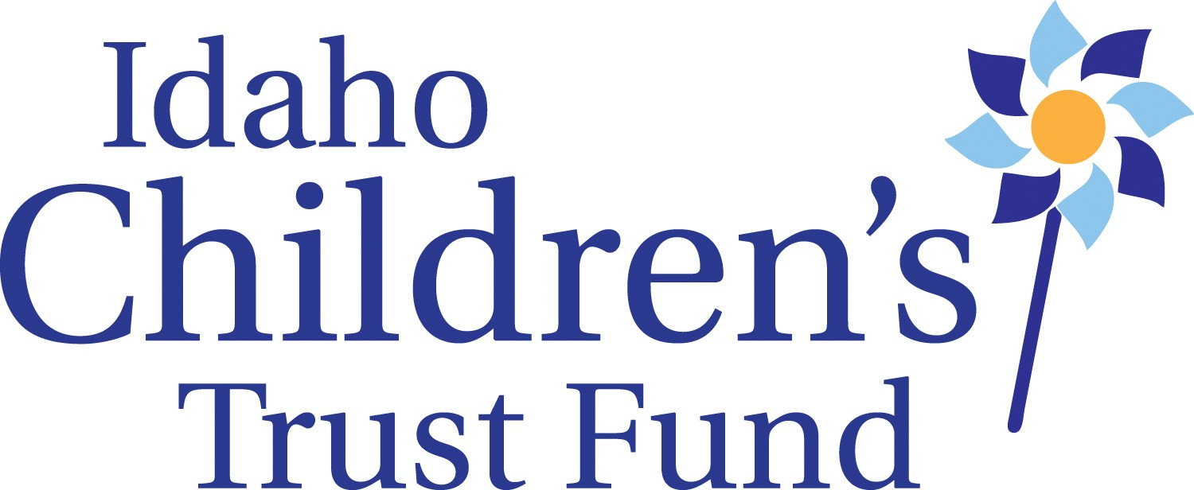
LOGIC MODEL
ICTF 2014

LOGIC MODEL

Organization Name: __________________________________ Project Name: _____________________________________________________________________

Population Served:
Population Need(s) to be Addressed by Project:
Services:

Only address the protective factors strategies relevant to the desired outcomes for your project.

Project Strategy/ Protective Factor | Outcome | Indicator (how you know if participants have achieved this outcome?) | Measurement (how will you measure change?) | How it meets your overall short-term or long-term goals?
Project Strategy/Parental resilience: The ability to cope and bounce back from all types of challenges
Project Strategy/Social connections: Friends, family members, neighbors, and other members of a community who provide emotional support and concrete assistance to parents
Project Strategy/Knowledge of parenting and child development: Accurate information about raising young children and appropriate expectations for their behavior
Project Strategy/Concrete support in times of need: Financial security to cover day-to-day expenses and unexpected costs that come up from time to time, access to formal supports like TANF and Medicaid, and informal support from social networks
Project Strategy/Children’s social and emotional development: A child’s ability to interact positively with others and communicate his or her emotions effectively

