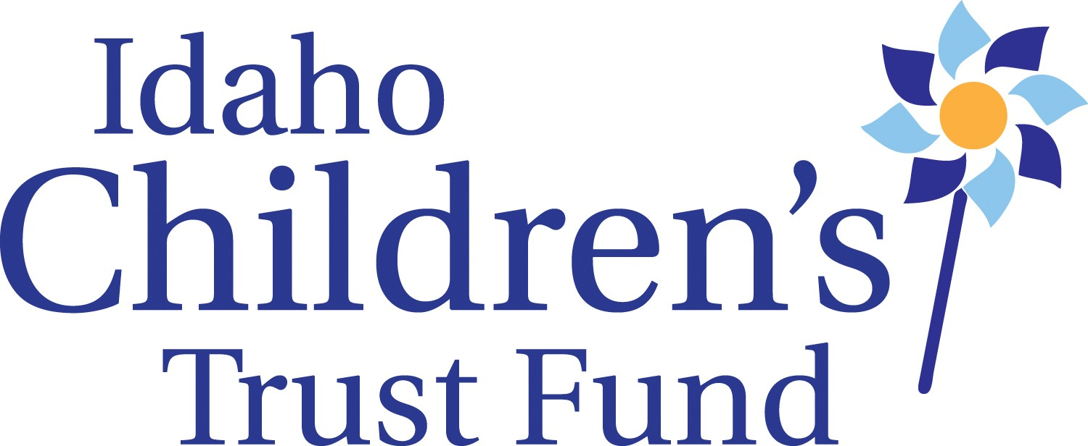

Idaho Children’s Trust Fund Board Meeting
January 20, 2016
Alexander House- 304 W. State St., Boise, Idaho
Meeting Minutes

Call to order: At 9:00am on Wednesday, Board Chair Sarah Leeds called the meeting to order

Board Members Present: James Herrmann, Sarah Leeds, Jill Andrus, Brenda Stanley, Janet Goodliffe, Amanda Pena, Shannon Dunstan, and Kay Christensen Absent: Jeanette Pinkham and Celia Asumendi

ICTF Staff Present: Roger Sherman, Lisa Newhouse, Taryn Yates

*SARAH MOVED to adjust agenda items on the Ed van Dusen Award and IDHW meetings to the beginning of the agenda because she will be absent in the afternoon.

Board Education- Janice, Idaho Non Profit Center, Fundraising planning and the Board’s role

ICTF/IDHW ongoing meetings
- Sarah and Roger met with Gary Moore to ensure ICTF is connected with IDHW
- Financial reports talked about in meetings and plan to meet with Kim Stearns, budget analyst to review fiscal procedures

Ed Van Dusen Award
Consideration was given to extend the date of the award nominations since currently the office had received only one complete application and two incomplete.
- Kay moves to NOT extend deadline and not to consider anything incomplete
Jamie second
Approved
- Subcommittee (Jaime, Amanda, Jill) to meet and review 1 complete application we have
- Sarah suggests we change requirements of award for next year as to not have this happen again

October Meeting minutes – Shannon moved to approve
Jill second
Approved

Consent agenda – Kay moved to approve staff reports and financial as reviewed by the Finance Committee
Amanda second
Approved

Review PCCA Assessment, Action Plan and Recommendations
- The board reviewed scores and comments from Re-chartering process with Prevent Child Abuse America staff and peer reviewers. ICTF as the state chapter of PCAA received high marks in all areas.
- What board education would be useful for us?
- Build a governance, action plan
- Create fundraising plan (Shannon, Sarah, Brenda, Janet)
- Sub committees don’t take minutes, report to board
- Executive committee tasked with creating a board assessment process
- Policy committee to determine need for and possible document on Succession Planning for board consideration
- Board wanted to clarify that although the Trust fund is the state affiliate of Prevent Child Abuse America, the board represents ICTF
Discussion of data, data needs and evaluation.

Board review PCAA policy positions –
Board approved a motion recognizing the Prevent Child Abuse America policy statements without endorsement.

KBOI
- Based on guidance from the purchasing division, working with KBOI-TV is permissible without a bid.
- Shannon motioned to move forward with getting contract from KBOI to bring to board
Brenda second
Approved

Multi Year Grant
- Taryn passed out timeline
- 2 new options of scoring and grant apps
- Option 1 preferred with rubric
- Add extra points for 1st time grantee, location, etc
- Taryn to update and present at next meeting

Child Abuse Prevention Activities
- Taryn will coordinate regional contacts around Child Abuse Prevention month activities
- Wear blue April 8
- Increasing SOC trainings
- Rally at Statehouse April 1
- Facebook posts ahead of time with events in each region

SFTI
- Went briefly over budget, introduced brochure and registration
- Discussed lists and invitations to ensure strong attendance

Expenditures over $1000
- $3,000 for online trainings
- SFTI budget about $20,000
- $5,000 for SOC books
- Jaime move to approve
Brenda second
Approved

* BOARD MEETING DATES SET FOR NEXT TWO MEETINGS*
- April 18th meeting set
- July 18th 1.5 day meeting in Boise set

Adjourn: At 1:45pm on Wednesday

