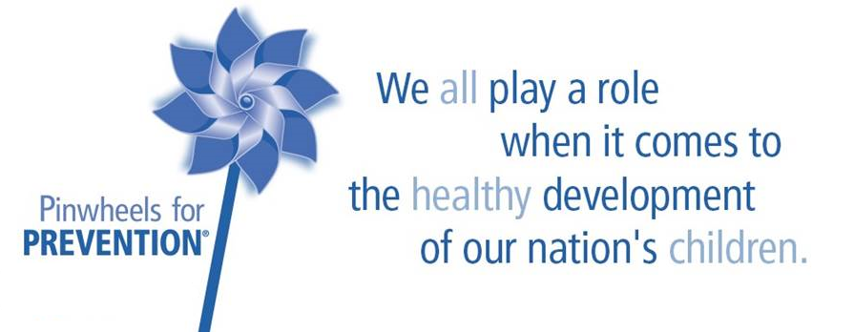

Child Abuse Prevention Month is just around the corner. It’s time to order PINWHEELS and more!
Item | Cost | Quantity Ordered | Total Cost
Pinwheels | $80.00/ Case of 192 Pinwheels ($0.42 per pinwheel)
Lapel Pins | $25.50/ Package of 10 Pins
Embroidered Stickers | $13.00/ 20 Stickers  $65.00/ 100 Stickers
Yard Signs (with Stakes) | $5.00/ Sign
ICTF will invoice you for your order.
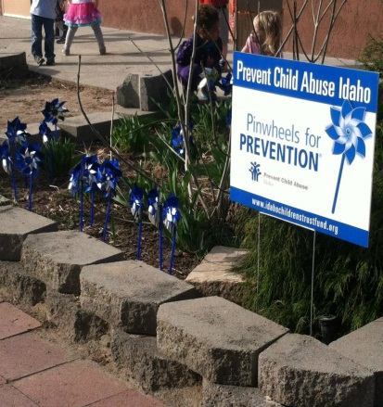
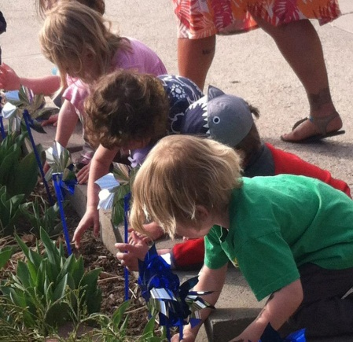
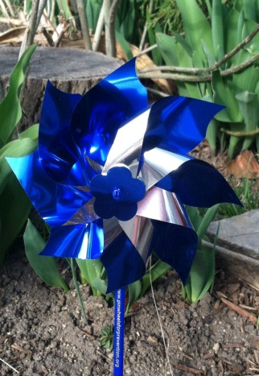

Orders can be picked up at the Strengthening Families Training Institute in March, 2016. Shipping arrangements can be made if necessary. *Awareness Grants are available to regional coalitions for up to $1000.00 and can be used to purchase pinwheels and other awareness supplies.*
Please contact Lisa at ICTF with questions and orders. newhousl@dhw.idaho.gov OR (208) 386-9317

