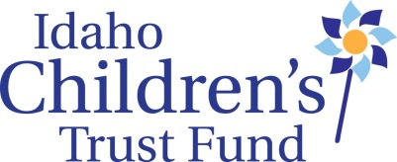
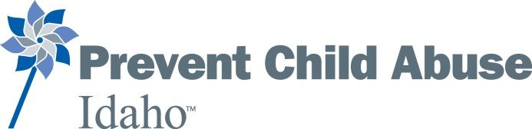

AGENDA
Idaho Children’s Trust Fund
Quarterly Board Meeting
Alexander House, 304 W. State St., Boise, ID.
January 20, 2015

Wednesday, January 20th
8:30 am Gather for light breakfast
9:00 am: Convene
12:00 pm: Working Lunch
4:00 pm: Adjourn

Morning Session

9:00 Convene/Check ins……………………………………………………………………………………Sarah Leeds, Board Chair

Board education?

*Approve Minutes of October 2015 board meeting

*Consent Agenda
  - Staff Reports
  - Financial Report (Reviewed by Finance Committee)

Review Prevent Child Abuse America Assessment, Action Plan and Recommendations
Proposed action steps for ICTF board (Assign to committees if approved):
1. Develop and undertake board assessment process (see attached)
2. Develop Fundraising plan
3. Emergency/Short Term Succession plan (See attached)

*Affirm statement: “ICTF/PCA Idaho board has reviewed PCAA national policy positions and acknowledged their awareness of them”
http://www.preventchildabuse.org/public-policy/read-our-position-statements

*KBOI project/Purchasing directive
After the presentation by KBOI staff at the October board meeting, ICTF staff was directed to determine whether an arrangement with KBOI would violate purchasing rules. Staff at the Division of Purchasing determined that this would fall under a recently developed directive that they extended from a narrower directive focused exclusively on public service announcements.
Policy Directive No. 11-04 DEC 2015
Exempts legal advertising, public service announcements, and purchase of copyrighted materials primarily available from the publisher from competitive bidding.
This policy directive exempts “ongoing public service oriented broadcasts for television, radio…”

Question for board: “Should ICTF/PCAI pursue the development of “Childhood Matters” (or DBA) in collaboration with KBOI including fundraising, sponsorships and program development in order to increase public education on child abuse and greater awareness of the Idaho Children’s Trust Fund?”

Working Lunch

Afternoon Session
Multi-year grants
- Review application
- Grant schedule

Child Abuse Prevention Month: Coordinated Statewide Activities

Strengthening Families Training Institute plans/budget

Ed Van Dusen Award nominations

ICTF/IDHW ongoing meetings—internal review process

Expenditures over $1000
--$3,000 for online training
--SFTI (as per budget)
--TBD

