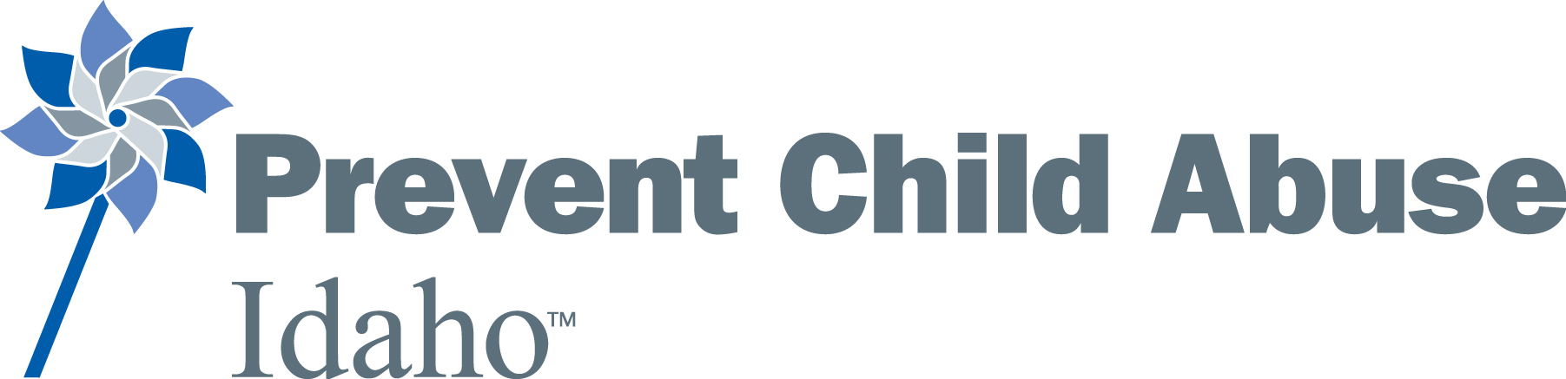
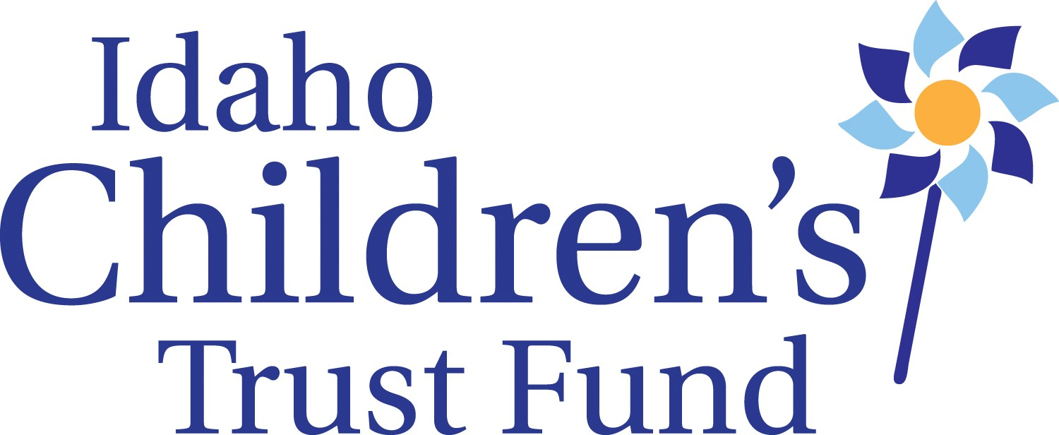

Idaho Children’s Trust Fund Board Meeting
October 19, 2014
Alexander House- 304 W. State St., Boise, Idaho
Draft Meeting Minutes

Call to order: At 9:00am on Monday, Board Chair Sarah Leeds called the meeting to order

Board Members Present: Celia Asumendi, Shannon Dunstan, Janet Goodliffe, Sarah Leeds, Amanda Pena, Brenda Stanley, Jill Andrus, Kay Christensen

ICTF Staff Present: Roger Sherman, Lisa Newhouse, Taryn Yates

Board Education- KBOI’s “Childhood Matters”

July Meeting minutes – Shannon moved to approve
Celia second
Approved

Consent agenda – Kay moved to approve
Shannon second
Approved

Internal Controls & Plan for Internal Audit Review
The new Administrator for FACS, Gary Moore offered to make budget analysis staff available to review ICTF internal controls and create an ongoing process for internal auditing
- Happening first week of November, Sarah requested to attend
- Board requested written record, recommendations and a presentation.

Janet motion to proceed with internal review
Kay second
Approved

Expenditures over $1,000
-Stewards of Children books
- 500 books @ $8/each
- Funding from St. Luke’s and Idaho Women’s Charitable Foundation

Janet motion to approve
Brenda second
Approved

Granting Decisions
-Taryn introduces matrix for applicants. Have $25,000 to give.
-Why do we have to use scoring method?
- Required by contract to show a score when giving out money
-Rubric vs ICTF value system. Tighten up rubric.
-Taryn to look into options in addition to scoring
- Provide examples to board
- 10 point criteria, yes/no answers, peer review, subject matter experts, let the criteria dictate: whoever wins, wins, either grant apps have info or it doesn’t.
- What are other places doing and is it working?
-Question to add to applications: Who are other funders and amounts?

The following grants were approved for funding:

5C (juveniles) Funded for $3,102

Community Council of Idaho Funded for $4,326
- Amanda motion to approve, Kay second

Families Together Funded for $5,000
- Kay motion to approve, Janet second

Family Advocates- Parents Anonymous Funded for $5,000
CATCH Funded for $4,470
Big Brothers/Big Sisters- not a lot of parent involvement Funded for $3,102

KBOI Discussion
-Roger was directed to research board concerns around purchasing protocol and DHW communications office relations

If possible a phone conference will be convened with at least 48 hours notice
-Shannon to set up a “go to meeting”

PCAA Site Visit Discussion

-Visit is just to ensure practices fit and get feedback on how to do work
-Exit summary and action plan will be developed and sent out
-
Kay moves to designate board delegates to present to PCAA site visitors and will clarify issues, answer questions, and report back at next meeting.
Janet seconds
Approved

Proposals

Proposal 1: Work with organizations in Magic Valley to fund VISTA training coordinator to build statewide child sexual abuse prevention initiative
Janet motions for Roger to move ahead with project as opportunity develops
Jill second
Janet amends motion to say staff should spend ‘a prudent amount of time’
*There is value in this so figure it out*
Motion approved

Proposal 2: Develop efforts to promote and pass “Erin’s Law” to provide education on child sexual abuse

Kay moves to table discussion until after 2016 legislative session
Amanda seconds
Approved

Adjourn: At 2:34pm on Monday

